Lab 2 Report | Parser

Nguyễn Tiểu Phương 20210692

As the instruction only requires the reporting of only one example, I choose **Example 2** – neither too long nor too short for demonstration purposes.

# Results

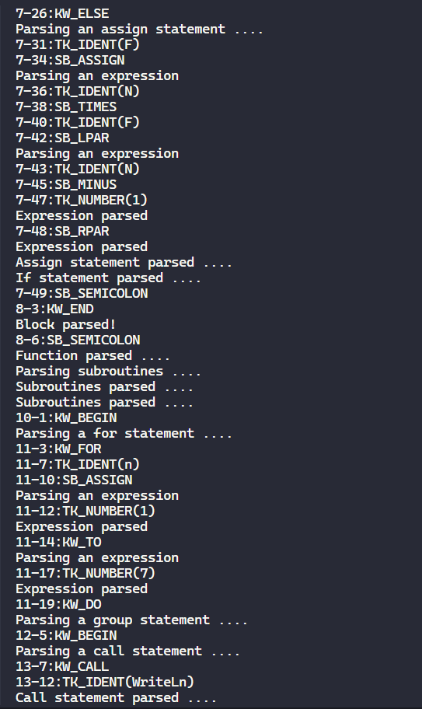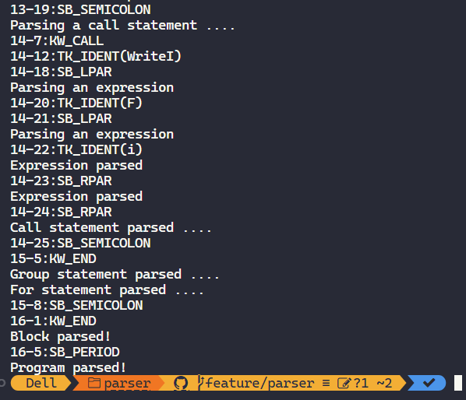

# Errors

Similar to Lab 1 report, we can invoke the errors by making certain changes to the source program.

The following errors are demonstrated each by 2 screenshots:

* one screenshot of the change in the source program,
* one screenshot of the corresponding output produced by the parser.

I underlined the changes and the errors in red.

## ERM_ENDOFCOMMENT "End of comment expected!"

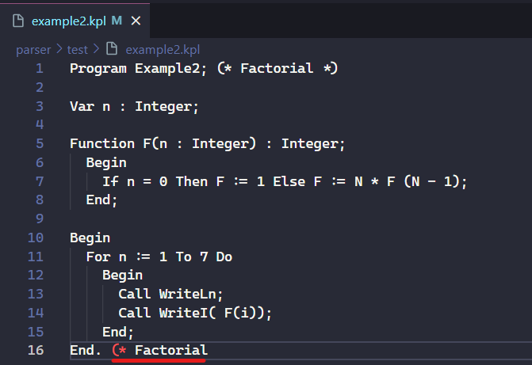

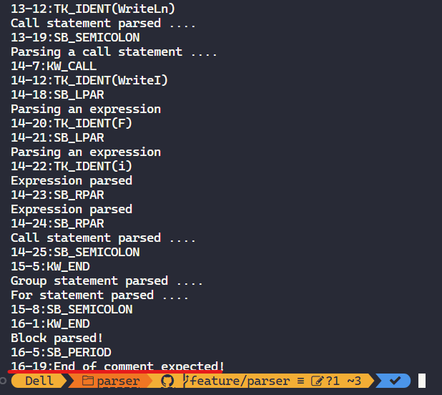

## ERM_IDENTTOOLONG "Identification too long!"

## ERM_NUMBERTOOLONG "Value of integer number exceeds the range!"

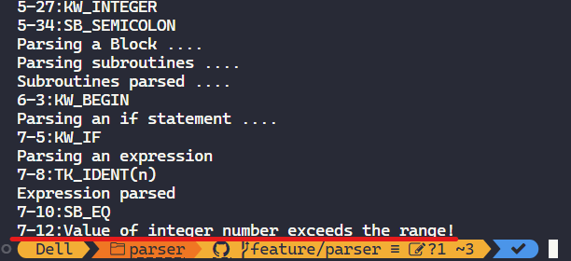

## ERM_INVALIDCHARCONSTANT "Invalid const char!"

## ERM_INVALIDSYMBOL "Invalid symbol!"

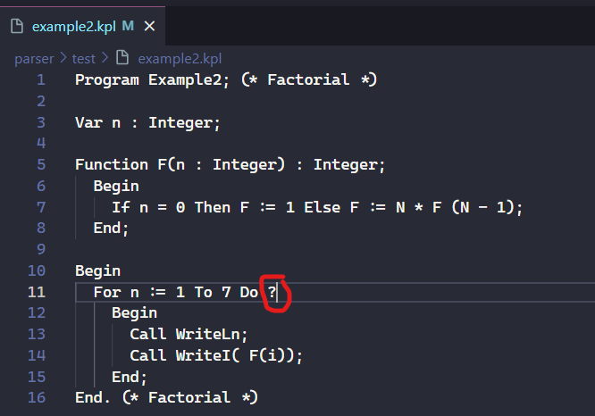

## ERM_INVALIDBASICTYPE "Invalid basic type!"

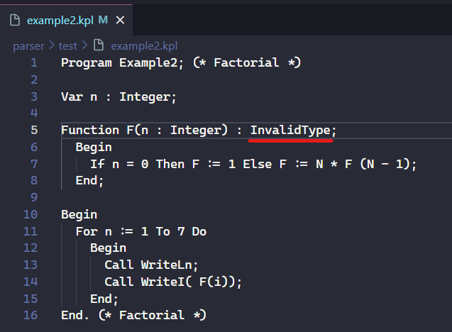

## ERM_INVALIDPARAM "Invalid parameter!"

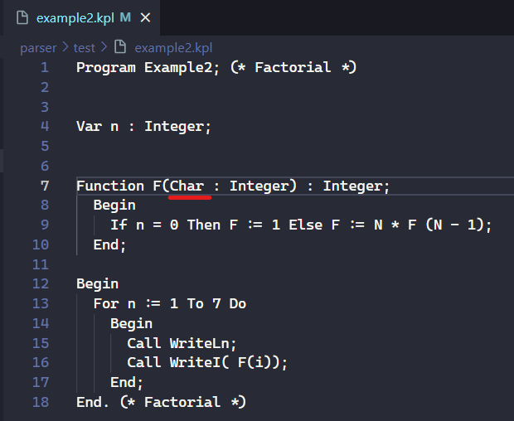

## ERM_INVALIDSTATEMENT "Invalid statement!"

## ERM_INVALIDARGUMENTS "Invalid arguments!"

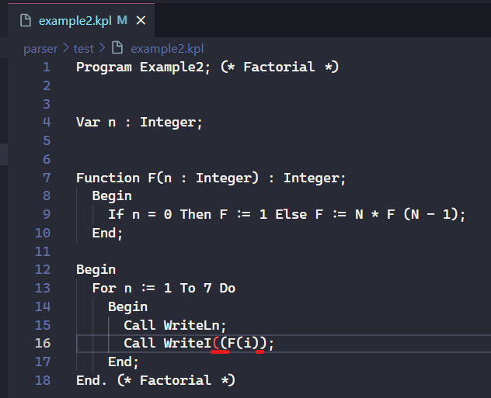

## ERM_INVALIDCOMPARATOR "Invalid comparator!"

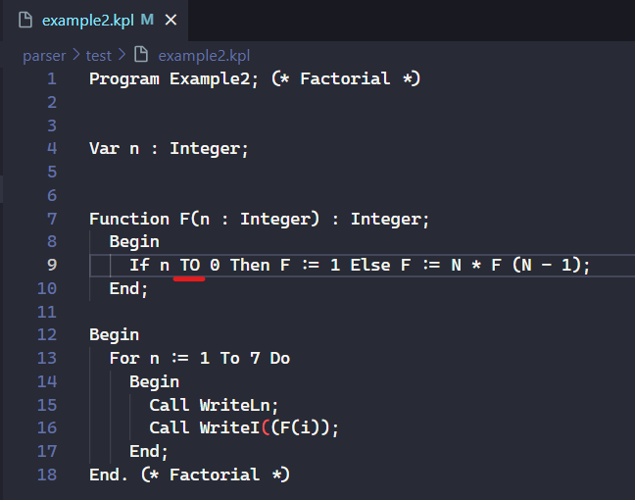 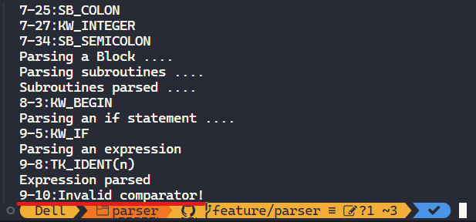

## ERM_INVALIDCONSTANT "Invalid constant!"

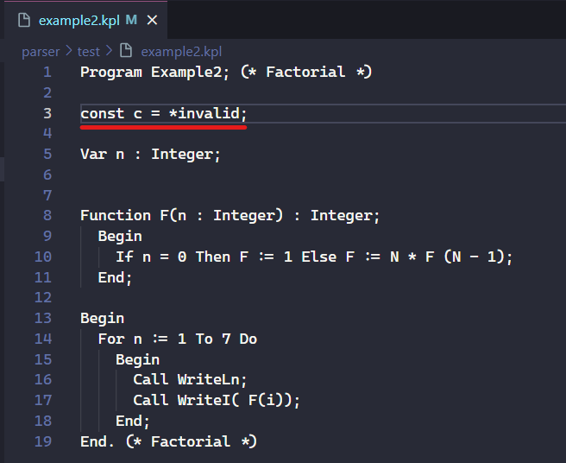

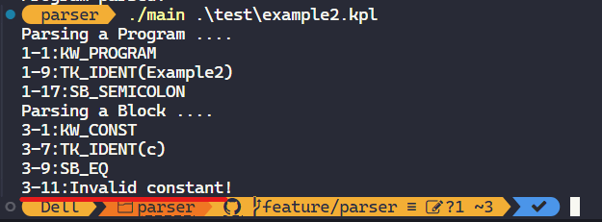

## ERM_INVALIDTYPE "Invalid type!"

## ERM_INVALIDEXPRESSION "Invalid expression!"

**This is not required in the assignment instructions.** To do this, we would need to compute FIRST and FOLLOW sets of all symbols – which is quite a demanding task itself.

## ERM_INVALIDTERM "Invalid term!"

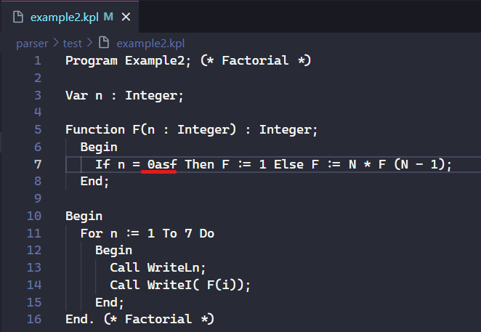

## ERM_INVALIDFACTOR "Invalid factor!"

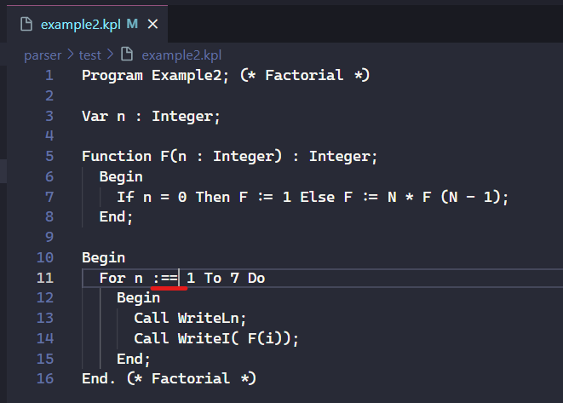

THE END